(Approx. 1,198 words)

Dad is probably not a Geek, but is most likely a Technophile!
By Lou Torraca, President, The TUG MOAA Computer User Group, Hawaii
www.the-tug.org
Af06hi (at) gmail.com

Father’s Day is June 17, so you have some time left to pick a goodie for him, and don't forget granddad and even great-granddad [since I'm all 3 had to put in a plug {:-)] Here are a half dozen ideas for u 2 consider:

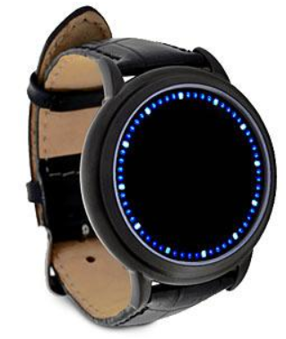

The Abyss LED Touchscreen Watch
Think Geek wrote the following about this watch, which I think is pretty nifty!

If you gaze for long into an abyss, the abyss gazes also into you. This watch is famous. Srsly, we wouldn't lie about something this important. Here's just a small snippet of the things it can do for you:
- Gives the ability to gaze into the abyss and come face to face with the true nature of your being
- Enables you to experience reality in four dimensions like a Tralfamadorian (no I don’t have any idea what that is either, but I suspect is has to do with aliens!)
- Use your knowledge of blue oyster cult numerals to control the Eye of Sauron
- Flaunt your disregard for the Temporal Proliferation Treaty of 3012
- Suck the souls out of your enemies, leaving them empty shells of the losers they once were
- Experience the horror (the horror) of the heart of darkness or blue lights like Tron
- Be friended on Facebook by such famous wizards as Merlin, Gandalf, and Dumbledore (he's not dead!)
- Get you into top secret locations without top secret clearance
- Instantly assess whether someone believes in midichlorians

Seriously, you'd better get your hands on this watch before we get a Cease & Desist from the Federation. This kind of technology just shouldn't be on the open market for any chucklehead to order and use. But we trust you nerds. At least, we trust you won't use your newfound powers to hurt us.

Now for the serious stuff-

Product Specifications:
- Japanese-inspired blue LED touchscreen digital watch
- Gently touch the screen to display the time
- Touch and hold to enter time setting mode
- Blue & white LEDs encircle the mouth of the Abyss
- Black, snakeskin-textured leather band with buckle clasp
- Powered by 2 - CR2016 batteries (included)
- Longer-than-average battery life since the time only displays when you tap the watch!
- ThinkGeek is not responsible if the watch drives you crazy…Me either {:-)

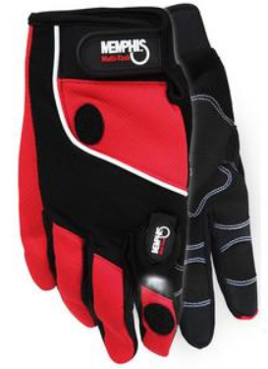

Lighted hands - the next step in human evolution
If you're trying to do difficult work in the dark (assuming you are) you need a pair of these LED Work Gloves. They allow you to focus beams of light on your work while keeping both hands free to do said work. Whether you're putting together computers, fixing the innards of your vehicle, or building a robot companion, a little extra light goes a long way.

One LED light with four attachment points on each glove (two lights per pair)
- Ergo-flex designed palm pattern
- Reinforced foam padded palm
- Neoprene cuff with pull tab closure
- Air flow panels in fourchettes
- Micro-textured grip enhancing polymer material gives you a firm grip on items, life
- Micro-terrycloth perspiration pad
- Double layered synthetic thumb
- Star stretch fabric so the gloves fit nice and snug
- Sizes S-XL

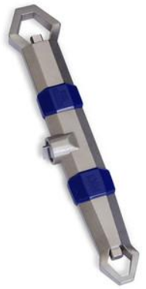
The Hydrokinetic Adjustable Wrench adjusts to the job
Doctor Who has his sonic screwdriver - a small tool that can adjust to any situation. It uses advancements in technology to provide an infinitely adaptable tool. While the Hydrokinetic Adjustable Wrench won't let you start up your TARDIS (that would be the time machine) it will let you fiddle with twenty three different sizes of bolts and nuts. And the secret resides in wrench's liquid core. Take a look at the little computer graphic cut-away, and you'll know what we mean.

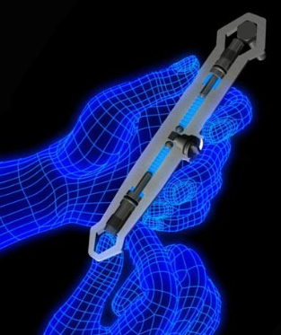
To adjust the Hydrokinetic Adjustable Wrench, just open the valve, fit around the nut or bolt of your choice, and push the gripper on the opposite end. It will compress the liquid which will, in turn, push the gripper on the end you want. Once it is snug against the nut, close the valve and your Hydrokinetic Adjustable Wrench is locked into position. It's that easy! The slim heads of the wrench will let you sneak it into tight spaces, and the design of the grip will help you turn even damaged nuts and bolts. Once you get your Hydrokinetic Adjustable Wrench in your hands, you will instantly know its power - which it looks like something from Doctor Who or Star Trek doesn't hurt either!

Features:
- Patented, liquid-core technology allows this wrench to adjust to fit almost any nut or bolt.
- Easily adjusts to 23 different sizes (metric and standard): 7mm - 19mm and 1/4" - 3/4".
- Slim, ergonomic design allows the wrench to fit into hard to reach areas.
- Great for removing even damaged nuts and bolts.
- Made of nickel plated, cold forged steel.
- Dimensions: 7.5" long



Custom Tie
Yes, the good old standby for gifts when u don’t know what to give the Dad who has it all!

What’s a tailored suit without a custom tie! Create one-of-a-kind ties for yourself or your loved ones. Upload your own images and patterns, or browse thousands of stylish designs to wear in the office or on the town.
- 55" long, 4" wide (at widest point).
- Unlimited colors.
- Made of silky 100% polyester fabric.

The ICON Link Flashlight
A flashlight is just one of those things that’s just good to have around. Whether it’s being prepared for a potential weather-related emergency or just having a good light source available in person or in your car, you just never know when you’ll need a flashlight. The Link by ICON is a great option for just such circumstances.

The Link is 4 inches long and has a carabineer clip, so the flashlight is easily stashable in the glove compartment or clipped to be within arm’s reach. The Link’s high strength aluminum body (3.1 oz) feels substantial yet not weighty in hand and is rugged (and waterproof) enough to take whatever you can dish out. But the selling point for any flashlight is the light And with both powerful 50 lumen and a useful 6 lumen outputs, the Link can shed the right amount of light under any condition with merely one AA battery.

A Great Gift For: Emergency preparedness, campers and of course, Father’s Day.

Baseball Prospectus 2012
And finally, all Dads are baseball fans…or at least wannabe fans, right? Here is the perfect gift for either.

Now in its seventeenth edition, the Baseball Prospectus annual shows once again how it became the industry leader: The 2012 edition includes key stat categories, more controversial player predictions, and the kind of wise, witty baseball commentary that makes this phone-book-thick tome worth reading cover to cover.

Baseball Prospectus 2012 provides fantasy players and insiders alike. Baseball Prospectus 2012 brings together an elite group of analysts to provide the definitive look at the upcoming season in critical essays and commentary on the 30 teams, their managers, and more than 60 players and prospects from each team.

Have fun and remember to be careful out there on the www.

Aloha, Lou

Read all of Lou’s columns at Oceanic Time Warner Cable's Community Website
http://www.aroundhawaii.com/technology_in_plain_english.html
http://bit.ly/f3TQ5t

